**Report**

**On**

**Registration System**

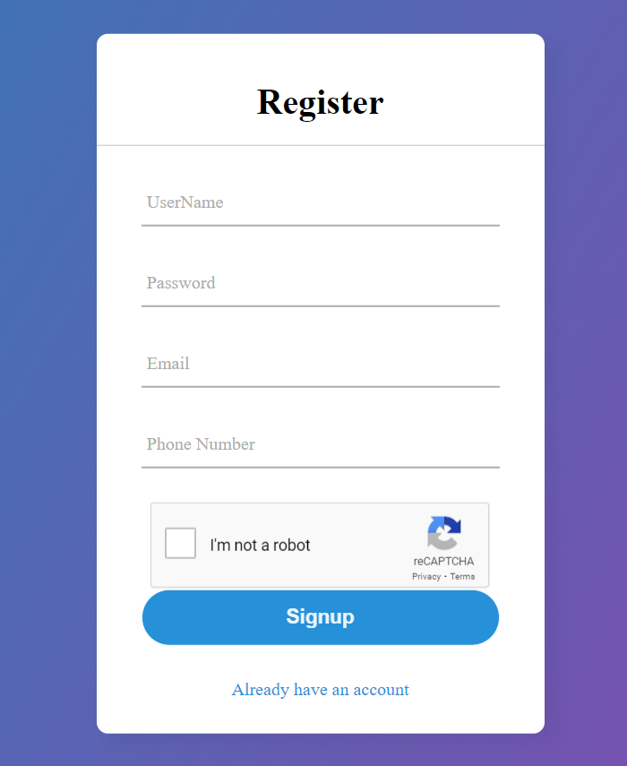

**Prepared By**

Name: Bisesh Shrestha

Student ID: **219570044**

Unit Code: CET324

Unit Title: Advanced CyberSecurity

Date: 6/10/2022

**Table of Contents**

**Introduction** 2

**System Requirements** 2

**Structure** 2

**Setup** 3

**Points to Remember** 3

**System Features** 3

**User Registration** 3

**User Login** 5

**Password Strength Checker** 6

**Captcha Validation** 7

**User Dashboard and Logout** 7

**Database Overview** 9

**Conclusion** 9

**References** 10

## **Introduction**

This technical report's primary goal is to demonstrate the User Registration System's full functionality. The users of this system will have access to a safe and secure registration and login process. This Secure Login System employs PHP as the server-side programming language and HTML, CSS, and JS as the frontend. The data obtained during registration is stored using the phpMyAdmin management tool.

## **System Requirements**

Below is a list of the prerequisites for this system:

1. PHP must be set up.
2. Any server that utilizes My SQL and Apache (I used xampp).

## **Structure**

To make it simple to understand the overall system's flow, the file structure is clearly illustrated below.

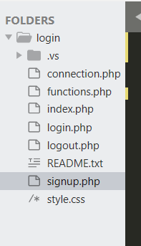

Fig-1: File structure

## **Setup**

We are one step closer to the setup page after meeting the requirements. Please follow the instructions:

1. Unzip the file first.
2. Store the main folder on your server in the localhost directory. (I am using C:\xampp\htdocs\login)

## 3. Locate the login database file, go to your MySQL server, create the user-registration database, and import it.

## 4. Next, open the "user-registration" directory on the localhost server. (<http://localhost/login/Signup.php>)

## **Points to Remember**

## Ensure that your database file and correct zip file are both present.

## Because captcha cannot be accessed without the internet, ensure that your internet connection is strong and reliable. (Used Google ReCAPTCHA v2)

## **System Features**

### This technique for registering users uses secure coding. It makes use of many validation algorithms to give users a safe environment and a clean database. This technology can efficiently reduce unnecessary data and traffic. Below is a detailed explanation of some of the system's most important and necessary features.

### **User Registration**

All users have access to registration features on this page. Additionally, it demonstrates the security of the password that the user is attempting to use while registering. Every person must prove that they are not robots when signing up using this mechanism. This is possible due to Google's reCAPTCHA v2.

**User Interface**



**Source Code**

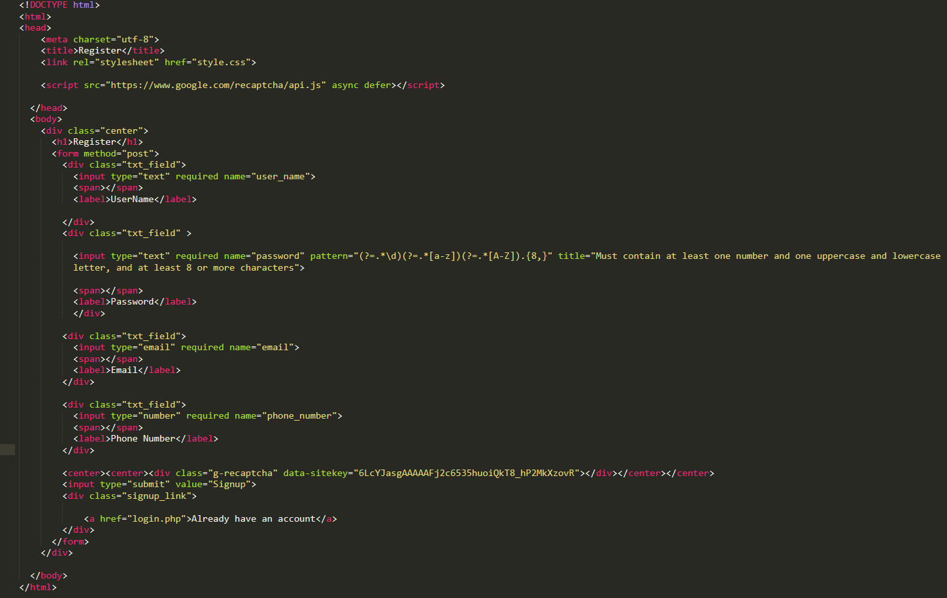

### **User Login**

All registered users may log in and access the user dashboard from this page using their current username and password. The server-side programming verifies if the user's username and password have previously been stored in the database or not when they are entered by the user. Users are sent to their dashboard if the login and password match the data that was found.

**User Interface**

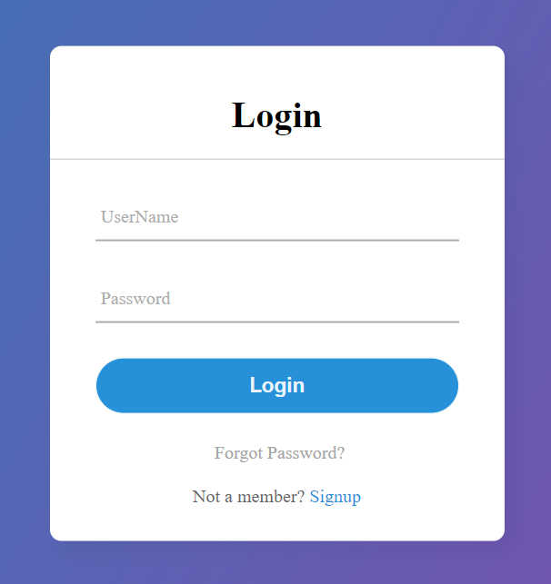

**Source Code**

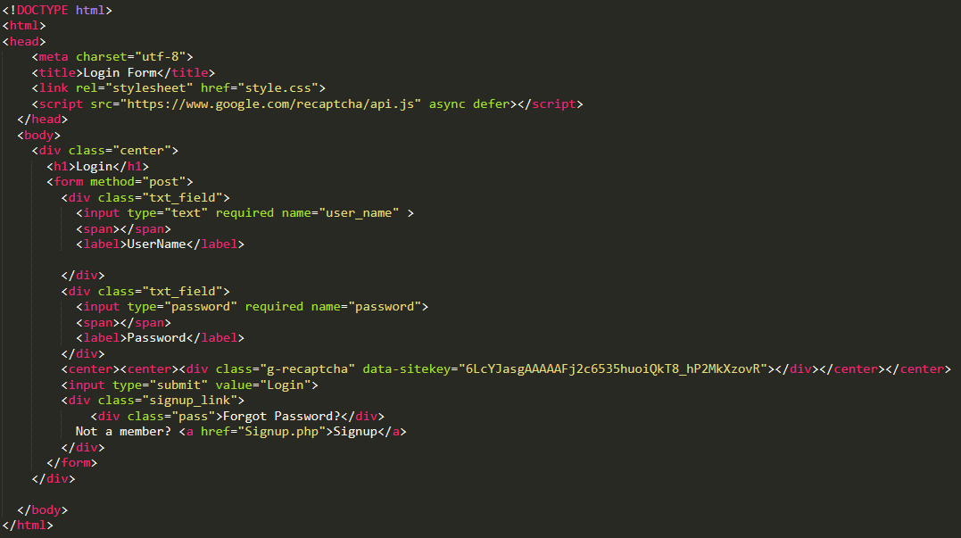

### **Password Strength Checker**

To validate the strength of the user-provided password, JavaScript is used. According to a survey, people struggle to generate secure passwords for both personal and professional accounts (Pittman & Robinson, 2020). Therefore, this system's password validation function is another strong point. I haven't utilized the display password option in this system because it doesn't give users a safe environment. The majority of secure systems even hide the number of characters that have been put in the desired area.

**User Interface**

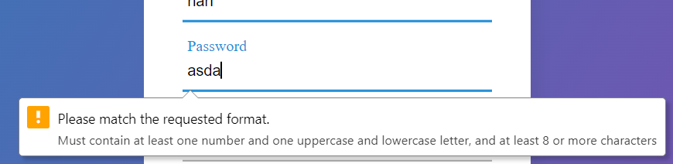

**Source Code (JavaScript Function)**



### **Captcha Validation**

The usage of captcha validation prevents unauthorized login and signup attempts. I've used Google reCAPTCHA v2 in this case. In essence, CAPTCHAs act as deterrents to automated systems since altered text can still be read by humans but cannot be read by current computer algorithms (Alalayah, 2021).

**User Interface**

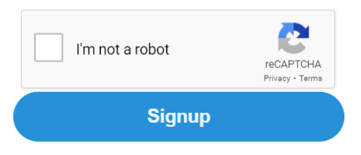

**Source Code**



### **User Dashboard and Logout**

Users may view their username on this user dashboard, and it also offers the option to log out from the same place.

**User Interface**

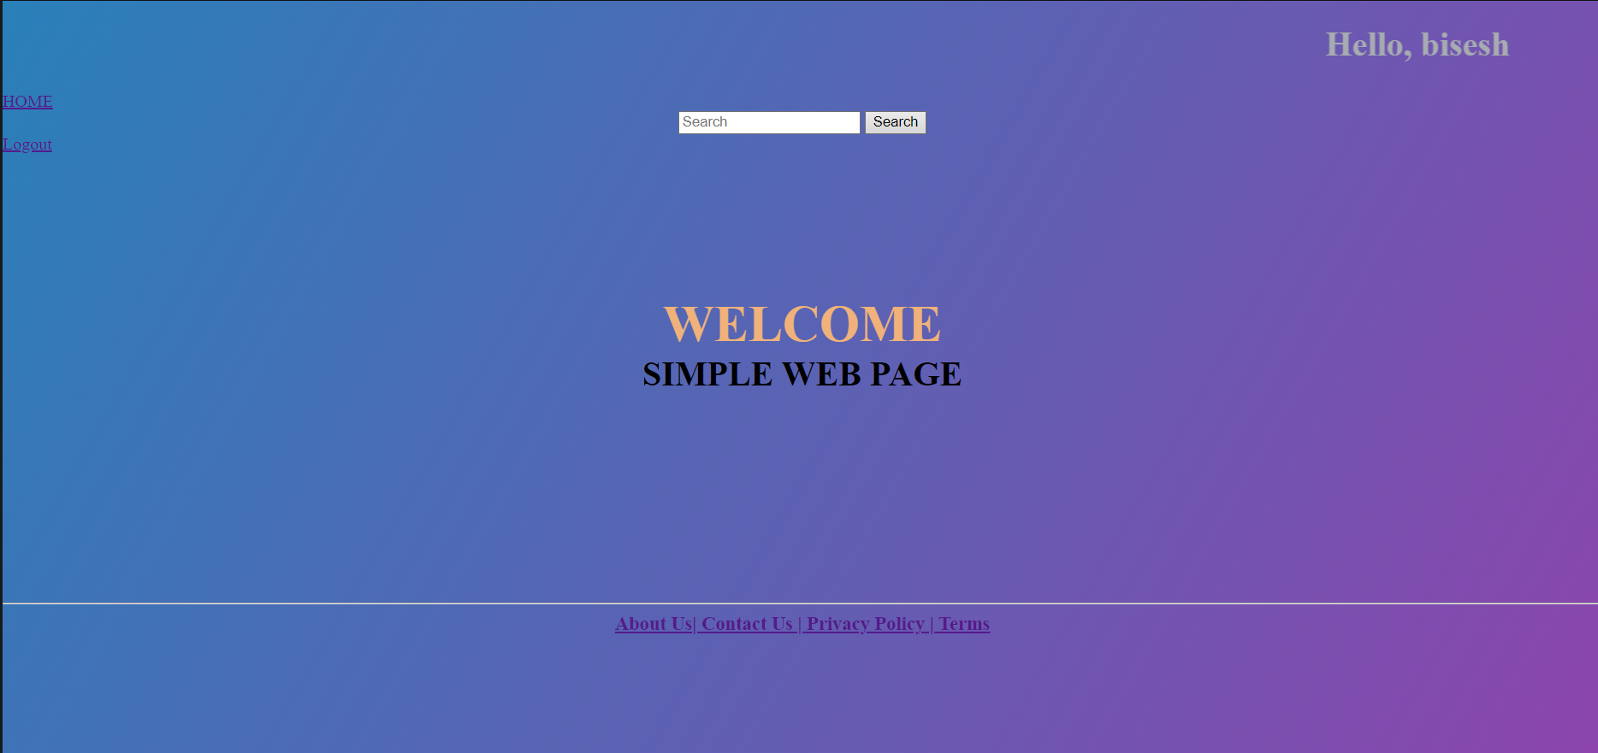

**Source Code (Dashboard)**

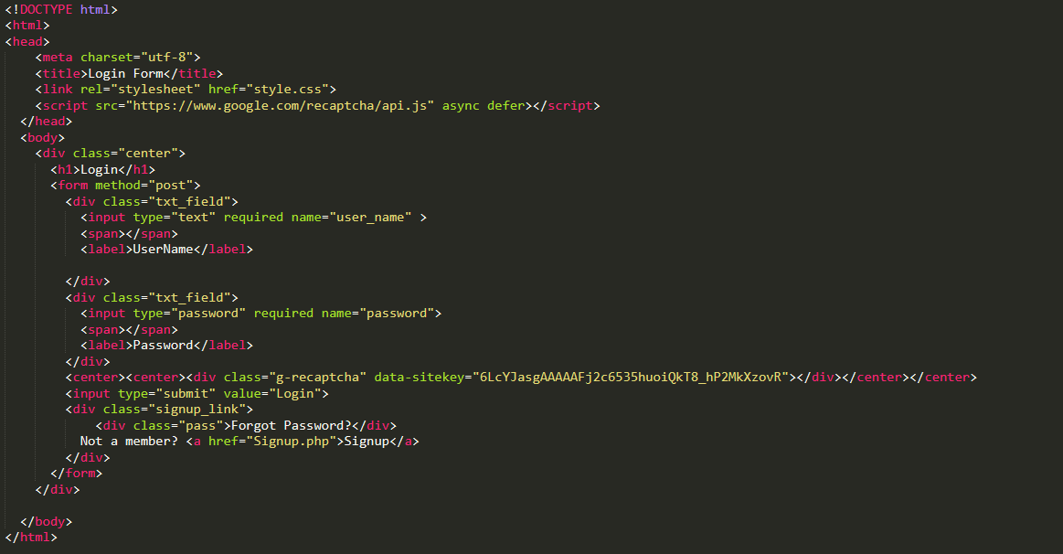

**Source Code (Logout)**

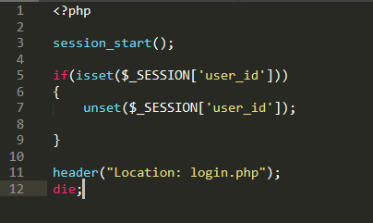

### **Database Overview**

All user information is kept in a database called "users." This system also uses a safe technique to encrypt the user's password.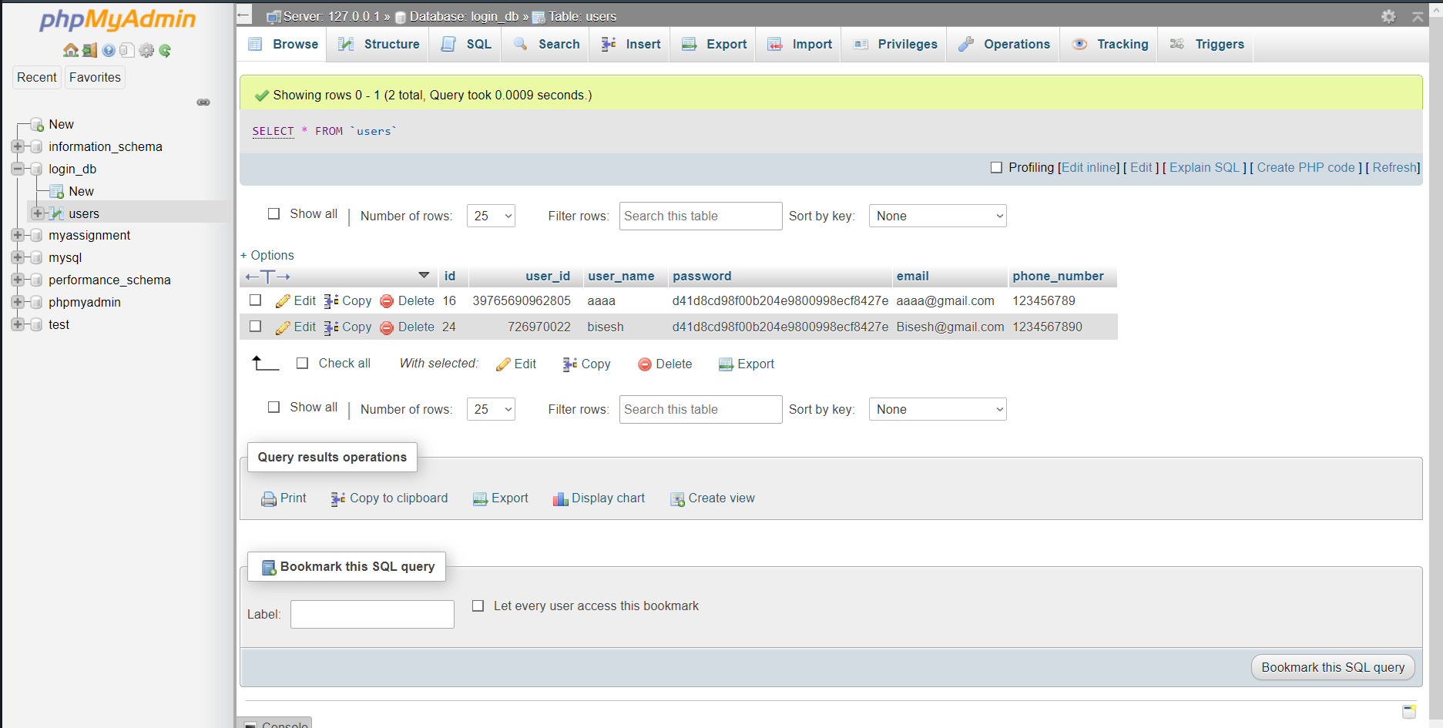

## **Conclusion**

Authentication is becoming more and more important as wireless communication technology grows quickly in order to guarantee the security of the system. This system has the potential to be one of the secure authentication settings, in my opinion. It has the potential to give its consumers a safe and secure domain. To provide users a secure and safe registration and login mechanism, this project might be a tremendous success. The user's password must be 6 characters long and contain a mix of upper- and lowercase letters, digits, and symbols, according to the registration system. By adopting OTP-based authentication, various improvements can be made.

# **References**

Alalayah, K. M. (2021). reCAPTCHA: Human Based Embedded Image Generation. *International Journal of Emerging Trends in Engineering Research, 9*, 950-952. Retrieved from http://www.warse.org/IJETER/static/pdf/file/ijeter19972021.pdf

Pittman, J. M., & Robinson, N. (2020). Do Users Correctly Identify Password Strength? *Journal of The Colloquium for Information Systems Security Education, 8*, 4-5. Retrieved from https://cisse.info/journal/index.php/cisse/article/view/123/123